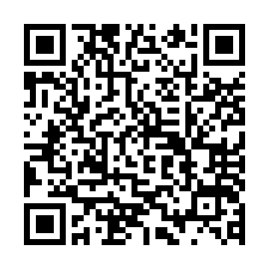
https://docs.google.com/forms/d/1qVYdM8OHIOk0HdC7fqtbhh1FXvliMlzH2H7P4mHdTh8/edit
R6.2.10東区P研修会申込
不鮮明

